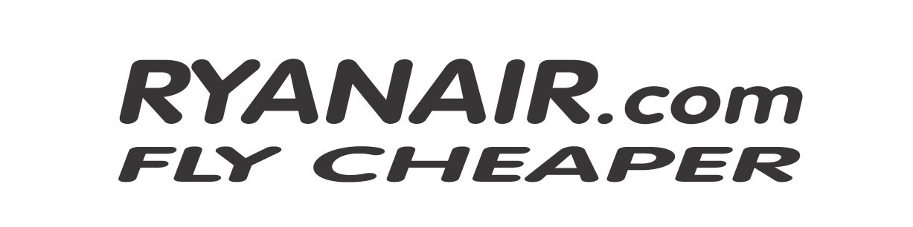

Double The Difference Application Form

Completed applications will only be accepted by email to priceguarantee@ryanair.com

Please complete the following information & submit

with your supporting documentation.

Details of your Ryanair Flight:

Passenger Name/s:

Confirmation Number:

Outbound Date & Departure Time:

Inbound Date & Departure Time:

Origin & Destination:

Return Fare Paid* Per Passenger:

Email (mandatory) for Correspondence:

Ryanair will not be held responsible for any email delivery failure.

Details of the Competing Airline offering a lower fare:

Name of Airline:

Outbound Date & Departure Time:

Inbound Date & Departure Time:

Origin & Destination:

Price* Quoted Per Passenger:

Date & Time of Quote:

Important – Please review prior to submitting your application:

*the return fare quoted will include all taxes, fees & charges but will exclude the credit/debit card handling fees, booking fees, baggage fees, web check-in, priority boarding or any other optional fees.

Claimants must submit a screen print of the competing airlines lower fare (which must include all taxes, fees & charges). Without this supporting documentation the claim will be rejected.

Please review offer terms and conditions before proceeding with your double the difference application. Ryanair’s decision in relation to all claims submitted will be final.

